BIM User Guide: March 2022
ACO Bridge drain

User Guide for Autodesk Revit files

ACO Bridge drain Package
Bridge drain is incorporated in a single Revit template along with accessories.
This template includes the following families:

- Bridge drain 300x500 D400
- Bridge drain 500x500 D400
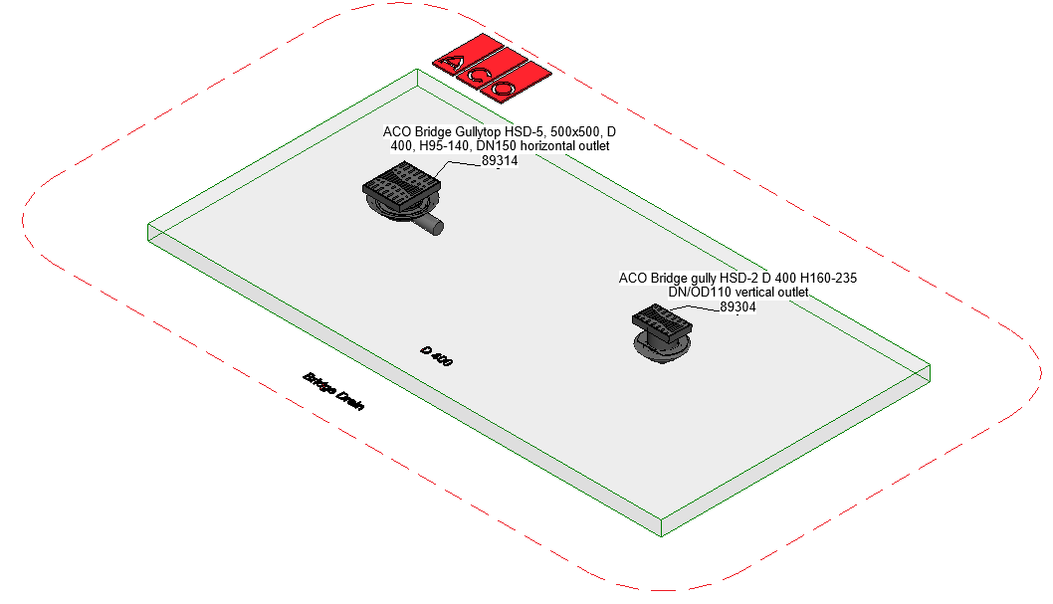

Loading ACO manhole cover into the project:
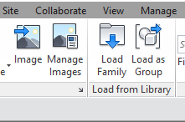
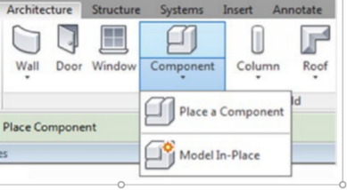
- Download the ACO Bridge drain project file and save it to a suitable location

- Select any one of the family from ACO Bridge drain and
load to your project

- Navigate to the “Insert” icon on the Revit ribbon and click “Load Family”

- The file can now be placed into your project. Navigate to the “Architecture/Component” icons on the Revit ribbon and click “Place a Component”

- Placing of “Bridge drain”

- Click on the model – At properties tool bar, it will display family name and types:- Bridge drain 500x500

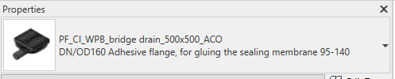

- Click on the model – At properties tool bar, it will display family name and types:- Bridge drain 300x500

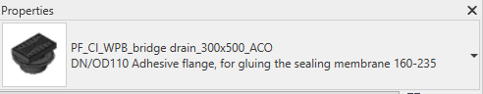

- Bridge drain 500x500 family consists of 5 family types; the user can select the family type from the “Properties” drop down menu

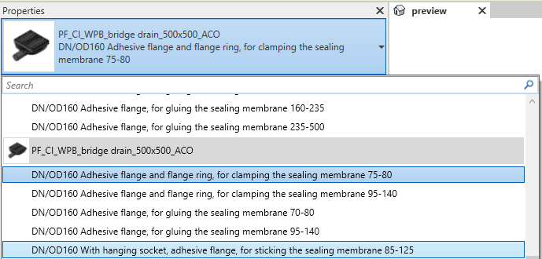
- Bridge drain 300x500 family consists of 16 family types; the user can select the family type from the “Properties” drop down menu

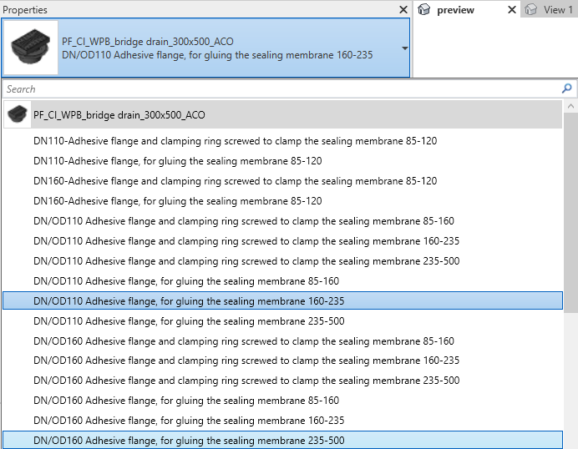

- After selecting the family type, the user can have multiple options like, selection of lettering frame, DN/OD Sanitary, height adjustment, Slope adjustment and related accessories as shown in image
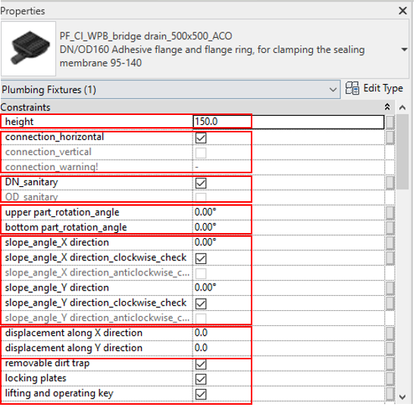

- Upper part (frame and grating) Height adjustment: The user can adjust the frame height by entering value range limits by looking H_min and H_max range and enter required height within the limits, if user enters value below or above the limits then warning pop up will display

- Selection of Horizontal/vertical: The user can select with Horizontal/vertical by selecting check box as shown in below image.
[Suppose is the user selects the combinations that are not available in product range warning will pop up as “Product Not available in the constraints tab and in the Schedule it will be displayed as “NA”(not applicable)]

- Selection of DN/OD Sanitary: The user can select with DN/OD Sanitary by selecting check box as shown in below image.

- Selection of Slope X/Y direction: The user can select with Slope either X direction or Y direction by selecting check box as shown in below image.
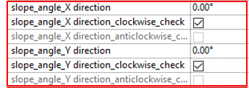

- Selection of X and Y direction displacement: The user can select with X and Y direction displacement by selecting check box as shown in below image.
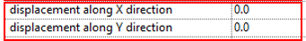

Workplane Based Families: The families are work plane-based families so they can be placed in flat surface and sloped surface of road as shown below

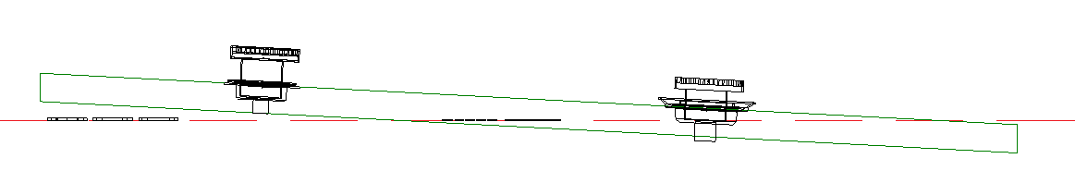

Material Library:
The ACO Bridge drain file contains materials that are already pre-loaded into the components. When loading the ACO Bridge drain file into your project the pre-loaded materials will automatically transfer through.

Schedules and quantities:

The information such as article number, GTIN data, weight, installation guidelines within the parameters is stored as “Shared Parameters” with LOD 400 so it can easily appear when creating a schedule and quantities in the project environment as follows

